Year 9 AEP Biological Sciences Research

Formative Assessment

Maker Model of Curriculum Differentiation Teacher planning
Adaptations

Content Modifications
Abstraction  The focus of discussions, presentations and reading materials should be on abstract concepts, themes and theories.  Example; Baudin’s Black Cockatoo  http://nokomis.com.au/cockatooplates.html  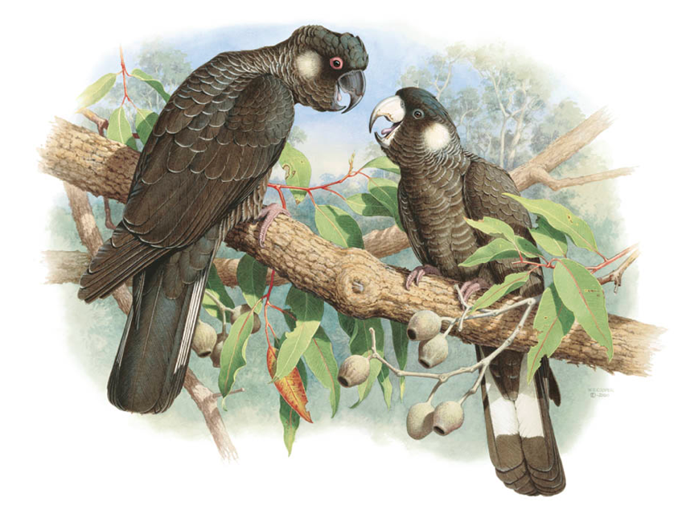 | Going beyond the facts  Adaptations:  Traits that function to increase survival or reproduction and are due to genes (i.e., are heritable) are called adaptations. Organism form and function are the product of many generations of evolution. Stories explain how adaptations work; how their function is better than some alternative.  Three Types of Animal and Plant Adaptation:  Structural Adaptation  Structural adaptation refers to physical features of an organism (shape, body covering, armament and also the internal organisation).  Example; Baudin’s Black Cockatoo, like all birds, have many bones that are hollow. This makes them very light-weight, which helps them fly.  Functional Adaptation  Functional adaptation, otherwise known as physiological adaptation, permits the organism to perform special functions (for instance; making venom, secreting slime, and phototropism) but to also perform more general functions such as growth and development, temperature regulation, ionic balance and other aspects of homeostasis.  Example; Baudin’s Black Cockatoo, like all birds, excrete nitrogenous wastes in the form of uric acid  Behavioural adaptation  Behavioural adaptation composes of inherited behaviour chains and/or the ability to learn. Some examples are searching for food, mating and vocalisations. Behaviours may be inherited in detail (instincts).  Example; What does Baudin’s Black Cockatoo do when threatened?
Complexity  Determined by examining the number and difficulty of concepts and disciplines that must be understood or integrated. | Dealing with greater breadth and depth  Interdependence of body organs and systems and the environment.  Adaptations and selection over time leads to conservation of favourable genotypes.
Variety  Students can work on different aspects of a broad theme and in their areas of interest. | Being exposed to new ideas or content  Individual students choose an example from the animal or plant kingdom.  Each student chooses one body system of their organism and explores the adaptations of this system to the environment of the organism.  Write a script for a story to explain how adaptations work; how their function is better than some alternative. Gather visual evidence and build an iMovie.
Organisation  Content is organised around key concepts or abstract ideas. | Selecting new arrangements of content  For the chosen body system;  Describe the body system and its parts.  Explain how the system functions in this organism.  Explain how this is an adaptation to the environment. You can do this by comparing the system of your organism to the human systems that you are learning about.

Process modifications
Higher-order thinking skills  Instructional methods should stress the use rather than the acquisition of information. | Using questions from the analysis, synthesis and evaluation area of Bloom’s taxonomy.  Demonstrate how the features of your chosen system help your animal survive in its environment
Open–ended processing  Questions are provocative in that they stimulate further thinking and  research into a topic | Encouraging divergent thinking  Are the speed and amount of modern climate change unprecedented?  Is dangerous warming of the earth occurring?  Is the temperature range observed in the 20th century outside the range of normal variability?
Discovery  Activities stimulate inductive  reasoning to find patterns and underlying principles. | Adopting an inquiry approach to determine own conclusions  Within each story;  Describe the form of the adaptation.  Explain how the adaptation functions.  Explain how the adaptation helps the organism survive in its environment.  Describe the evidence for this.
Proof and reasoning  Students are required to explain the reasoning that led to their conclusions.  Students learn about other students’ approaches and learn to evaluate reasoning processes. | Being required to give reasons, substantiate conclusions.  Pairs of students present their story on their organism and its body system and how this helps it to survive its environment.  Class takes notes on each.
Freedom of choice  Choice of activities can be motivating and independent learning can meet the gifted student’s preference for self-regulation. Some students need support to become independent learners. | Choose one organism and one adaptation only. The following are some ideas. You are free to choose a topic of your own.  - How does the digestive system of a kangaroo, rabbit, cow, chicken, cockatoo or polar bear help it survive in its environment?  - How does the use of metabolic water in desert mammals eg Spinfex Hopping Mouse Notomys alexis  - How does temperature control in a lizard, kangaroo, horse, dog or fish help it survive in its environment?  - How does the excretion of nitrogenous waste in a fish, bird, frog or turtle help it survive in its environment?  - How does the respiratory system of lizard, kangaroo, horse, dog, cockatoo or crocodile help it survive in its environment?  - How does the circulatory system of fish, amphibians, reptiles, birds other mammals help survival in its environment?  - How do plant adaptations for water loss, low soil nutrients (eg Banksia), high salt concentration in soil help survival in the environment?
Group interactions of like-ability peers  Structured and unstructured activities should be provided to enable both intellectual and socio-affective goals. | Enabling group problem-solving  Individual students research and present an iMovie.  Cooperative discussion of the presentations  Individual written evaluation answering the provocative questions. The written evaluation will be conducted in class and will involve comparing the human systems learned and the adaptation chosen to research.

Product modifications
Real–world problems  Products should address problems that are meaningful to the students | Investigating real-life problems  Adaptations of species to environment change over geological time.
Real audiences  Gifted students are not developing products that are evaluated only by the teacher. | Using products for evaluation by teachers, peers, community, and particular readership.  iMovie/podcast to Teacher and peers  Lectures to Year 8 AEP students
Evaluations  Gifted students’ products should be evaluated by appropriate audiences, their peers and themselves | Undertaking teacher assessment and student evaluation using pre-established criteria.  Individuals research and present.  Cooperative discussion of the presentations.  Peer evaluation of the adaptation story within the movie.  Individual written evaluation answering the provocative questions.

•Remember to include your name, date and references.

Vocabulary
- adaptation
- genotype
- form and function
- acclimation
- trade-off
- diffusion
- heart chambers
- metabolic water
- surface area to volume ratio
- efficiency

Prepared by CJMorritt
Baudin’s Black Cockatoo  http://nokomis.com.au/cockatooplates.html | Year 9 AEP Biological Sciences Research  Formative Assessment  Adaptations  Build an iMovie Project  Adaptations of a species to their environment

Adaptations:
Traits that function to increase survival or reproduction and are due to genes (i.e., are heritable) are called adaptations. Organism form and function are the product of many generations of evolution. Stories explain how adaptations work; how their function is better than some alternative.

Three Types of Animal and Plant Adaptation:
Structural Adaptation
Structural adaptation refers to physical features of an organism (shape, body covering, and the internal organisation).
Example
Baudin’s Black Cockatoo, like all birds, have many bones that are hollow. This makes them very light-weight, which helps them fly.

Functional Adaptation
Functional adaptation, otherwise known as physiological adaptation, permits the organism to perform special functions (for instance; making venom, secreting slime, and phototropism) but to also perform more general functions such as growth and development, temperature regulation, ionic balance and other aspects of homeostasis.
Example
Baudin’s Black Cockatoo, like all birds, excrete nitrogenous wastes in the form of uric acid

Behavioural adaptation
Behavioural adaptation composes of inherited behaviour chains and/or the ability to learn. Some examples are searching for food, mating and vocalisations. Behaviours may be inherited in detail (instincts).
Example
What does Baudin’s Black Cockatoo do when threatened?

The interaction of an organism’s adaptations and environmental selection over time leads to conservation of favourable genotypes.

Your Task
- Individual students choose one organism from the animal or plant kingdom.
- Choose one body system of the organism and explore the adaptations of this system to the environment of the organism.
- Write a script for a story to explain how this adaptation works; how its function is better than some alternative.
- Your iMovie should be about 5 minutes in length and include a spoken story explaining how the adaptation suits the environment and how it is better than some alternative. Include visual evidence such images, videos and animation. Original visuals are preferred.
- Include your name, Title, date and references.
- Your iMovie will be submitted to Mrs Morritt and will be assessed by both peers and teacher.

Your Topic
Choose one organism and one adaptation only. The following are some ideas. You are free to choose a topic of your own.
- How does the digestive system of a kangaroo, rabbit, cow, chicken, cockatoo or polar bear help it survive in its environment?
- How does the use of metabolic water in desert mammals eg Spinfex Hopping Mouse Notomys alexis
- How does temperature control in a lizard, kangaroo, horse, dog or fish help it survive in its environment?
- How does the excretion of nitrogenous waste in a fish, bird, frog or turtle help it survive in its environment?
- How does the respiratory system of lizard, kangaroo, horse, dog, cockatoo or crocodile help it survive in its environment?
- How does the circulatory system of fish, amphibians, reptiles, birds other mammals help survival in its environment?
- How do plant adaptations for water loss, low soil nutrients (eg Banksia), high salt concentration in soil, help survival in the environment?

Evaluation
There are two types of evaluation associated with your research.
Formative evaluation
Peer and teacher evaluation of the adaptation story within the iMovie.

Summative evaluation
In class, on a date to be advised each student will write an extended response comparing the human systems with the adaptation of a chosen animal or plant.

Vocabulary
adaptation caecum
genotype respiration
form and function photosynthesis
acclimation nitrogenous waste
trade-off carbohydrate
diffusion lipid
heart chambers protein
metabolic water efficiency
surface area to volume ratio

Formative Assessment
iMovie Rubric: Adaptation Student Name:

Title:

Criteria | Below expected level  2 points | At expected level  3 points | Above expected level  5 points
Introduction of topic | Topic introduced. | Topic introduced clearly, and purpose of iMovie was made clear. | Topic introduced clearly and in an interesting way. Purpose of iMovie was made clear. Outline of points was given.
Development of topic | Some understanding of topic shown. Some links and connections made between ideas. Points are usually developed with minimum detail. Information is usually relevant. | Good understanding of topic shown. Links and connections between ideas made clear. Information was relevant and expressed in own words. Points were developed with sufficient and appropriate details. | A very good understanding of the topic shown. Links and connections between ideas made clear. Information was relevant and well expressed in own words. Points were well-organised and developed with sufficient and appropriate details.
Ability to engage and involve audience | Techniques used to engage audience were minimal, or mainly ineffective. | An interesting approach taken to topic. IMovie used techniques such as visual aids, animation, images, videos, surprising facts. | An interesting or original approach taken to the topic. IMovie used techniques such as visual aids, original animation, original images, original videos, surprising facts, humour.
Suitability of iMovie for purpose and audience | Attempts were made to tailor the iMovie content to the intended purpose of informing, interesting or persuading. | The iMovie content and structure was tailored to the audience and to the intended purpose of informing, interesting or persuading. | The iMovie content, structure and delivery were closely tailored to the audience and to the intended purpose of informing, interesting or persuading.
Vocabulary, sentence structure, grammar | The science vocabulary of the iMovie was mainly appropriate for the topic. The iMovie content was occasionally grammatically correct. | The science vocabulary of the iMovie was appropriate for the topic. Sentence structures were usually correct. The iMovie content was usually grammatically correct. | The science vocabulary of the iMovie was appropriate for the topic. A variety of phrases and sentence structures were used. TheiMovie content was grammatically correct.
Conclusion of topic | An attempt was made to conclude the iMovie. | The iMovie was summed up clearly. | The iMovie was summed up clearly and effectively, with key points emphasised.

Further Comments;

