Summary of Light Properties
Reflection and Refraction

Light Property | Written Definition and Description of image | How we perceive this | Drawing of rays and component that causes light to change.  Follow the conventions for drawing light rays | Applications for the use of this property
Reflection
Plane mirrors and
Curved mirrors

Pearson9
Page 132

Refraction  Pearson9 Page 133 |  | 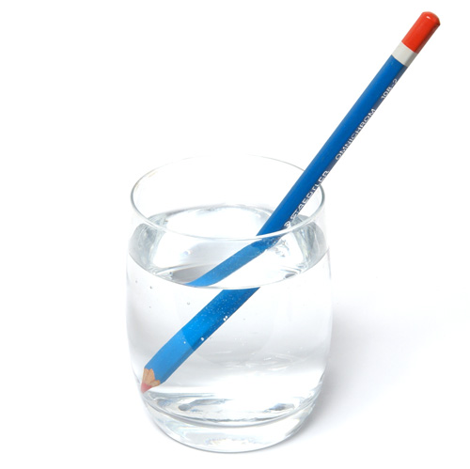
Refraction with convex lens  Pearson9 p134-135 |  | 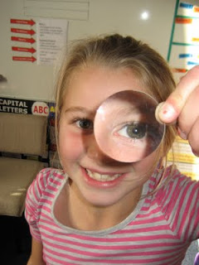
Refraction with concave lens  Pearson9 p136-137 |  | 