Electromagnetic Waves Jigsaw

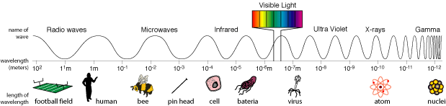

http://science.hq.nasa.gov/kids/imagers/ems/waves3.html

Waves that form the electromagnetic spectrum:
radio waves, microwaves, infrared, optical, ultraviolet, X-rays, and gamma-rays.

Home Groups of seven students.
Number off 1 to 7 and choose your wave.
- radio waves
- microwaves
- infrared
- optical
- ultraviolet
- X-rays
- gamma-rays.

Expert Groups of about four students
All waves of the same type join together to help each other research the following questions.

- State the wavelength of this wave.
- State the frequency of this wave.
- State the medium through which this type of wave can travel.
- Describe how the wave is produced.
- Describe the effect of this radiation.
- Explain how this wave is detected.
- Describe how we use the energy from this wave.
- Find an animation of your wave.

Electromagnetic Waves Jigsaw

Note-taking sheet for Expert Groups

Question | Response
- State the wavelength of this wave.
- State the frequency of this wave.
- State the velocity of this wave.
- State the medium through which this type of wave can travel.
- Describe how the wave is produced.

- Describe the effect of this radiation.

- Explain how this wave is detected.

- Describe how we use the energy from this wave.

- Find an animation of your wave.

