Australia’s Geological Past – Summary of iMovies

Eon  (Lengths of time) | Era  (Lengths of time) | Period  (Lengths of time)  Millions of Years Ago (MYA) | Representative Landscape | Significant events  Temperature, Atmosphere,  Sea levels, Paleogeography | Significant events  Flora and Fauna | Mass Extinctions and plausible reasons | Gondwana  Australia | Fossil  Examples
 |  | Quaternary | 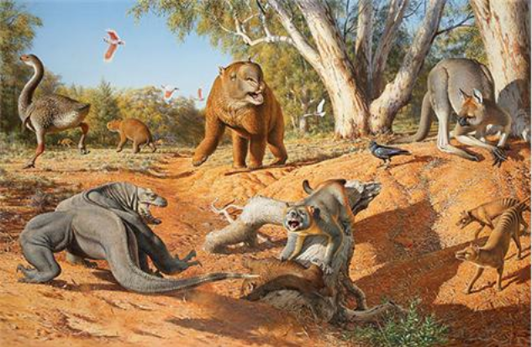
 |  | Neogene  Paleogene | 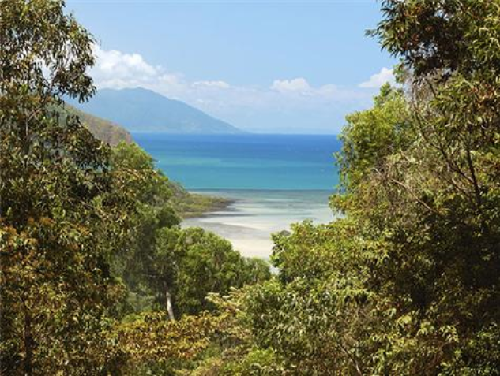
 |  | Cretaceous | 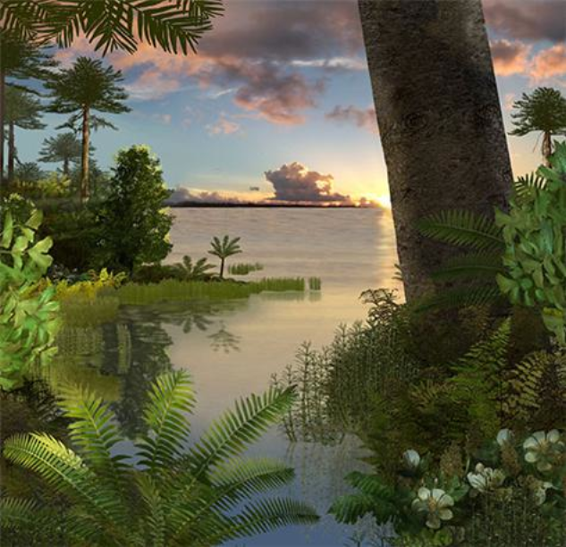
 |  | Jurassic | 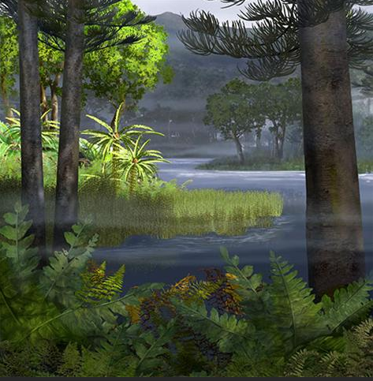 |  |  | Triassic-Jurassic mass extinction
 |  | Triassic | 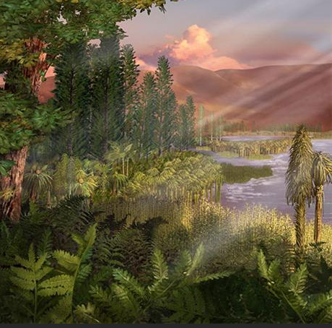
 |  | Permian | 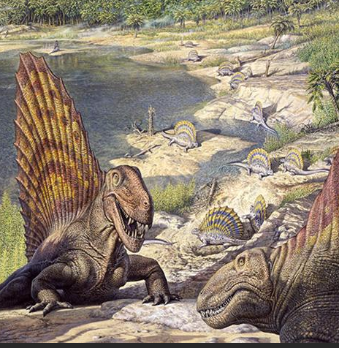 |  |  | Permian mass extinction
 |  | Carboniferous | 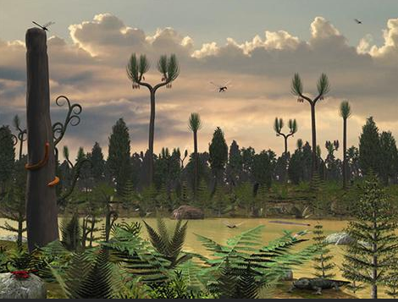
 |  | Devonian | 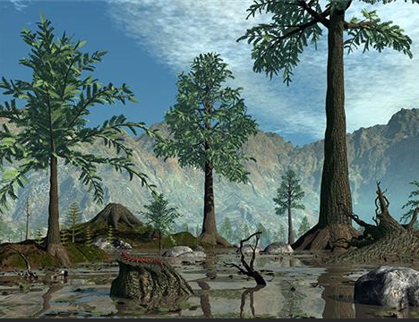 |  |  | Late Devonian mass extinction
 |  | Silurian | 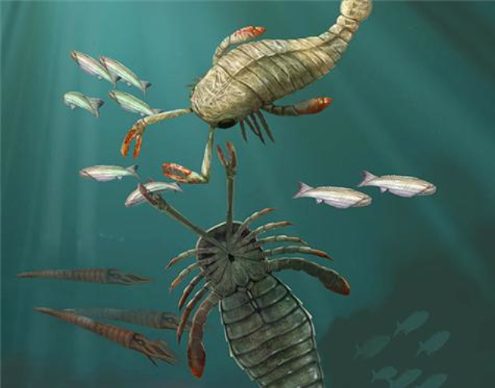 |  |  | Ordovician-Silurian mass extinction
 |  | Ordovician | 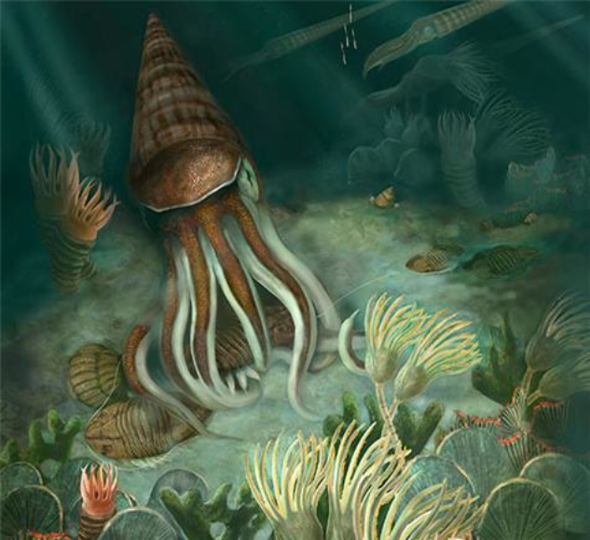
 |  | Cambrian | 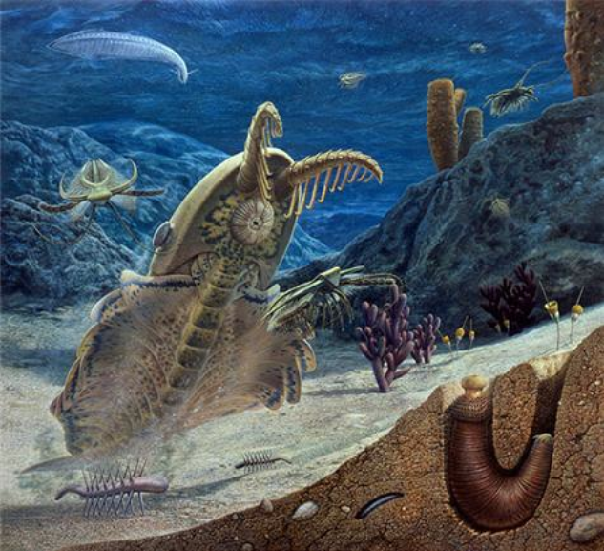
 |  | Edicarean  635–542 | 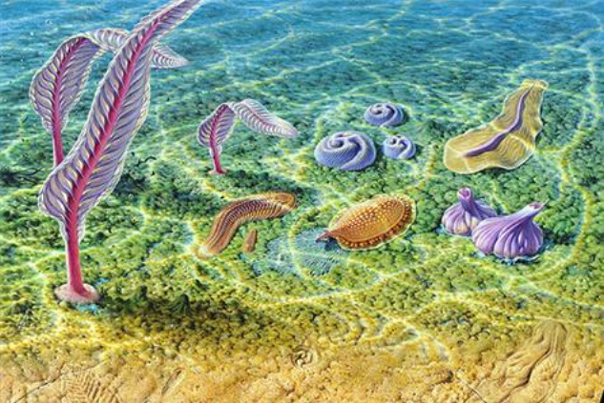 |  | Life evolves in the oceans

