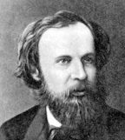 Demitri Mendeleev | A BRIEF HISTORY OF DEVELOPMENT OF THE MODEL OF THE ATOM

Date  Scientist | Observation from experiments | Inference about model of the atom | Significance to the atomic theory
1810  John Dalton  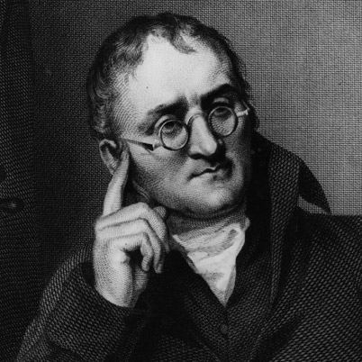 | "Elements always combine in the same ratio by weight in making a given compound." This is the LAW OF DEFINITE PROPORTIONS. | Matter is made of indivisible particles that were indestructible but combined together, in simple proportions, to make compounds.  Atoms of different elements differed in mass. | The first scientist to explain the behaviour of atoms in terms of the measurement of mass.  Write balanced chemical equations
1904  Sir JJ Thomson  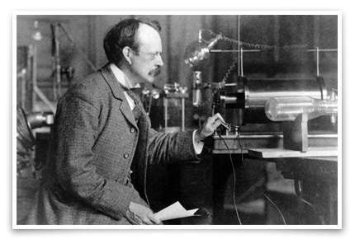 | Cathode ray tube – negative charges  first measured the ratio of charge to mass, e/m, of these small mass, negatively charged, high velocity particles called electrons. | “Plum pudding” model  (choc-chip muffin)  showed the existence of a negatively charged particle, termed the electron, which existed as part of the atom. | Showed that atoms are not indivisible.  Today electrons are used in electron microscopes
1911  Ernest Rutherford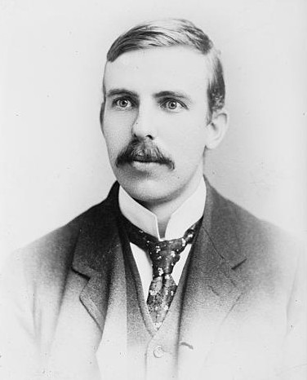 | Gold foil experiments | Discovered that the nucleus of the atom is very small in relation to the entire atom. He proposed that the negatively charged electrons were revolving in a “cloud” around a heavier, charged nucleus. | Electrons are on the outside of the atom.  This means it is the electrons that can be  - shared to form molecules or  - transferred to form ions
1911  Niels Bohr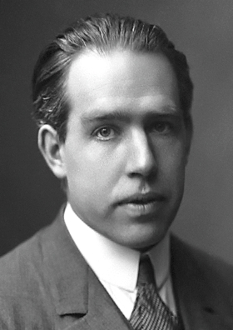 | Refined Thomson and Rutherford’s experiments with mathematics and physics | Synthesised Rutherford's discovery into a reasonable model of an actual atom, using hydrogen as his example. | The electrons are arranged in certain energy levels, or shells.  Electrons can jump up energy levels by absorbing energy and emitting energy as photons as they fall back to their original level. We sense this as coloured light.  Contributes to understanding of nuclear fission.
1932 to Present  Many scientists working and collaborating build the Quantum Model | Particle accelerators | In all atoms electrons are spinning and moving in sub shells within the energy levels.  The three fundamental particles are made of even smaller particles | Applies to all atoms, not just hydrogen.  The study of spectral lines shows us the quantity of energy each sub shell can hold.

