The Physics of Heat Transfer and how animals regulate their body temperatures.
Describe the methods of heat transfer
  - conduction
  - convection
  - radiation
  - evaporation
Explain how adaptations are used to regulate body temperature in endotherms and ectotherms.

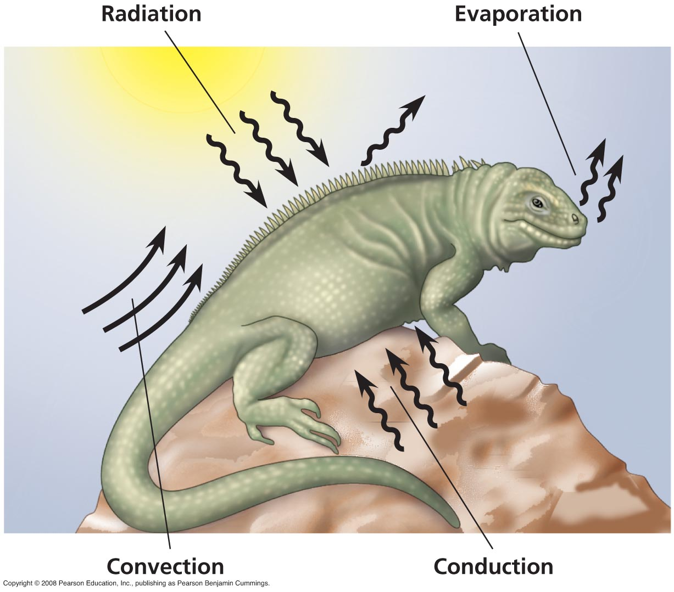
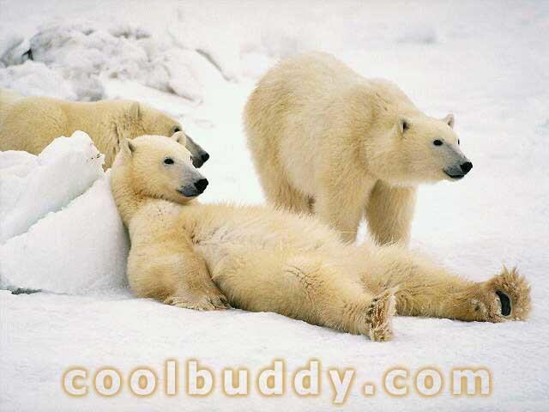 | Physical Principles Radiation  Heat travels through space from the surface of a _____________ body to the surface of _________________ body
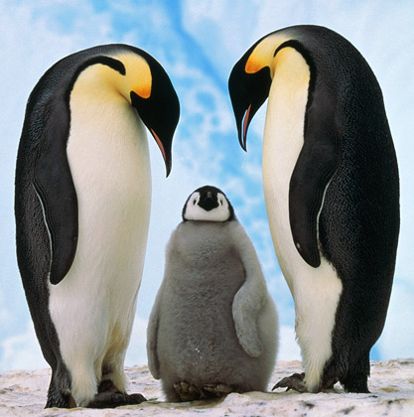 | Radiation  The greater the surface area of a body, the greater the radiation.  Small animals have a _____________  surface area to volume ratio than _____________ animals.  Small animals radiate heat more ___________ than large animals.  ____________ is a better absorber of radiation and a better radiator than ______________

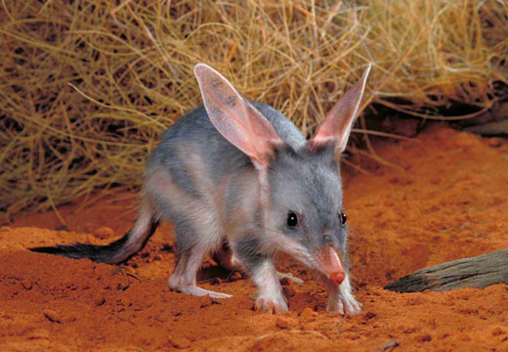
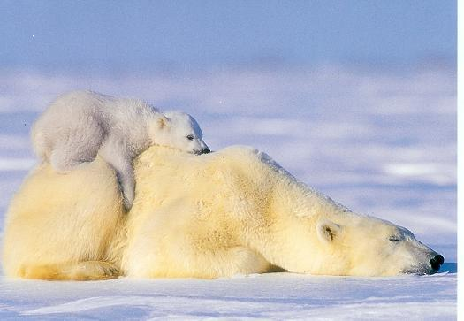 | Physical Principles Conduction  Heat flows from _________ to _________.  Conduction occurs when an animal is in contact with a surface like
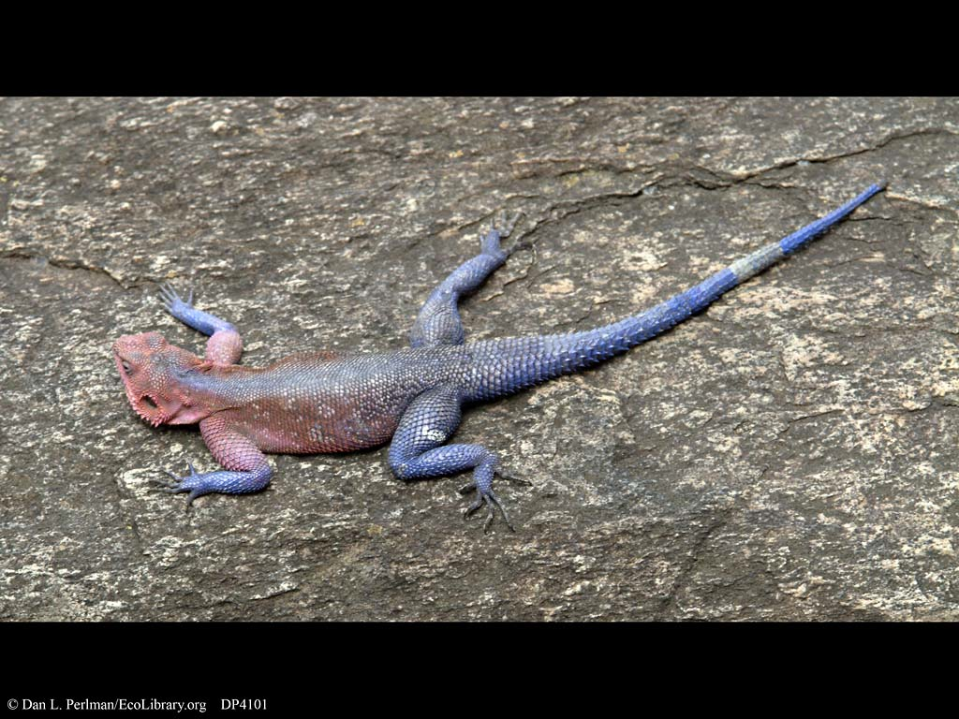

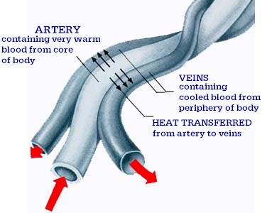 |  | Counter Current Exchange
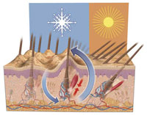 | Convection  Hot air ___________ away form a hot body.  Convection may be controlled by structures such as _____________, _____________ ,  _____________ which trap warm air. When hairs erect or stand up it is called pilo erection.
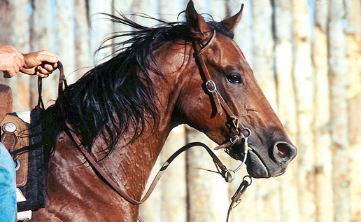 | Evaporation  Sweating involves ___________________ of water from the skin surface and removes _________________ from the body as liquid water turns to _________________ . For sweating to be effective the air must be _______________

