Elimination and Excretion

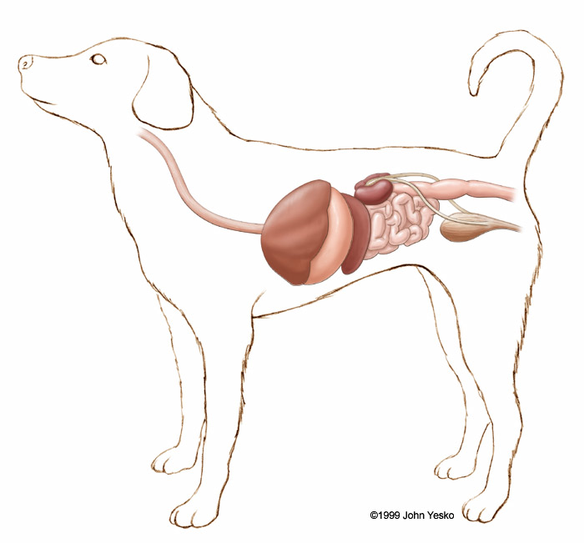 | Elimination
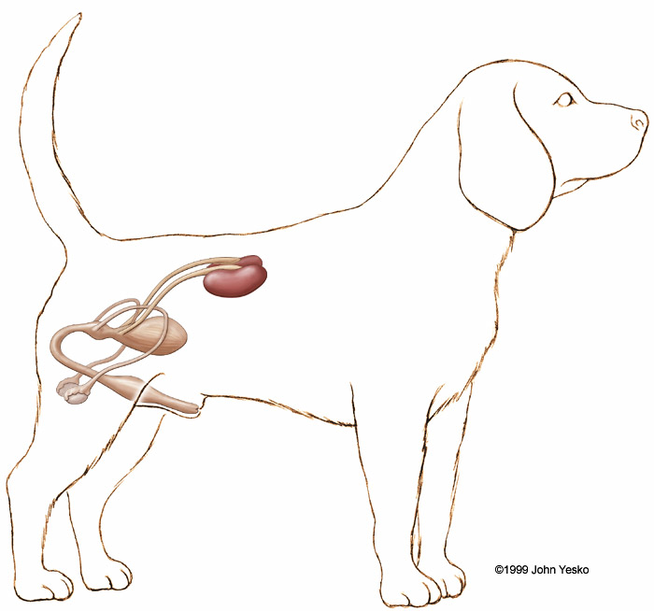 | Excretion – the Urinary system
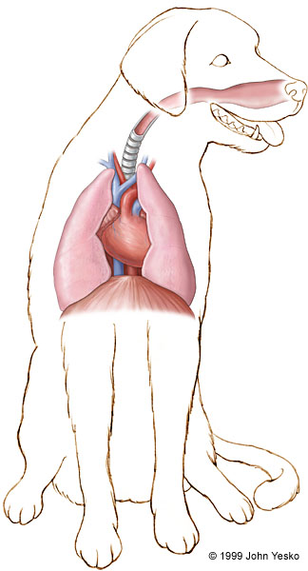 | Excretion – the Respiratory system  Respiration is a cellular chemical reaction that takes _______ (sugar) and ______ to produce e______ . But it also produces ______ and _____ ______ as bi-products.
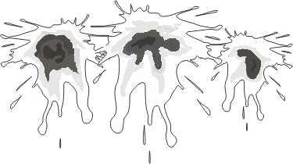

The Human Urinary System

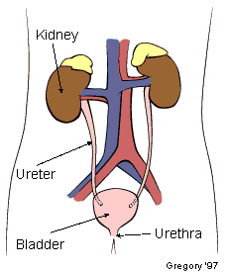
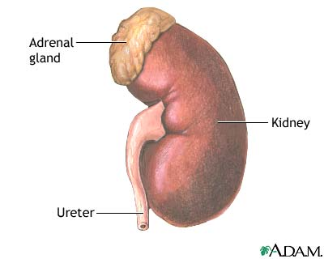 | The Kidney
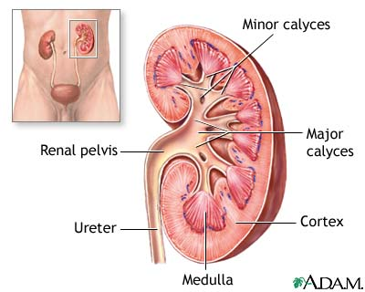 | The Kidney - Longitudinal Section

