Task 2 Energy Transformations and Transfers

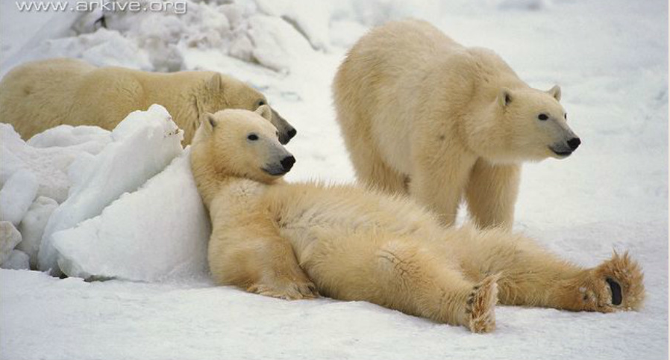

- The Polar bear (Ursus maritimus) is a mammal. List the adaptations that are common to all mammals.

- One adaptation that is common to all mammals is that they maintain a constant body temperature even though their environmental temperature changes. Draw a flow chart to show how chemical potential energy from food is converted into heat energy in the mammal body.

- Heat is transferred from regions that are hotter to regions that are cooler. Show on your image all of the places that heat is lost from the polar bear body. The arrow indicates the direction of heat flow.

- Different environmental conditions call for different methods of heat transfer. List the four different ways that heat may be transferred from regions of high heat to regions of low heat. Define each of these four methods of heat transfer.

- Label the arrows on the polar bears with the four different methods of heat transfer.

- Adaptations to heat transfer may be classified into three types;
  - Structural adaptation - physical features of an organism
  - Physiological adaptation - permits the organism to perform special internal functions
  - Behavioural adaptation - inherited behaviour chains and/or the ability to learn.

Describe some adaptations that help the polar bear maintain a stable internal body temperature under such conditions.

