Identifying the Minerals in Granite

Granite is the signature rock of the continents. More than that, granite is the signature rock of the planet Earth itself. The other rocky planets—Mercury, Venus and Mars—are covered with basalt, as is the ocean floor on Earth. But only Earth has this beautiful and interesting rock type in abundance.  Wave rock near Hyden WA is a granite outcrop that has been weathered into a wave-like shape. | 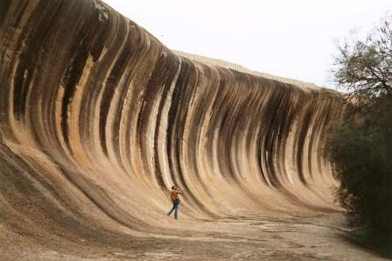
Granite is made of large mineral grains that fit tightly together. (The name granite means grains.)  Granite always has two light minerals, which you will identify. It can have varying amounts of a wide variety of dark minerals as well. You should be able to identify at least one of these dark minerals in your sample. | 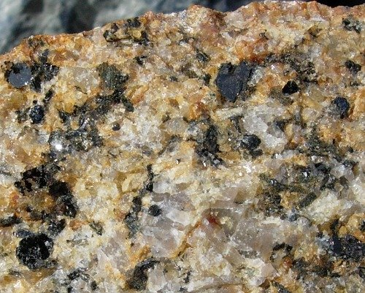

Your task is to use a dichotomous key to identify two light minerals and one dark mineral found in your granite sample.

Materials:
binocular microscope Sample of crushed granite
paint brush to separate grains dichotomous key to minerals
dropper bottle HCl (hydrochloric acid)

For each mineral you must list the feature of the mineral that led you to its name.
For example;
First property | Second property | Third property | Name of Mineral
Light colour | softer than copper | does not fizz in acid | Talc

First property | Second property | Third property | Name of Mineral in Granite

Write a conclusion about the minerals found in granite.

________________________________________________________________________________________________________________________________________________________________________________________________________________________________________________________________________________________________________________________

