The Binocular Microscope

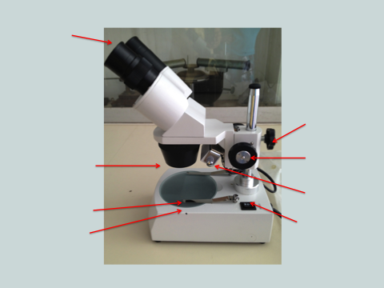

Complete the sentences using the words: hold, lamp, seen, bigger, lens, object, magnification.

Name of part | What it does
Ocular lenses | Bends the light to make the object seem _________________.  This is called m____________________________.
Objective lens | Can be changed so that the o ______________ may be magnified more or less.
Stage | Where you place the __________________________ to be magnified.
Stage Clips | H ___________ the object you are looking at in place
Coarse Focus and Fine Focus knobs | Moves the lens up or down so that the object can be _____________________ clearly. This is called focusing.
Lamp | Directs light on to the __________________ .
Switch | Turns on the upper __________________ .

